

Find **the house in the picture** below and add it on your favourites list.

Contact the seller via email.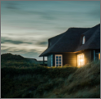

Go to the **search settings** and **increase your view distance**.

Go back to **the map**.

Find your **f*avourite house OR like the one in the image*** and put it on your favourites.

From Favourites contact the seller via email.

Done! :)